STUDENT BODY GOVERNMENT
Minutes – Thursday, September 26, 2013
- ATTENDANCE
Name | Title/Position | Present
Jad Gore | President | Yes
Carey Ballard | Vice President | Yes
Bridget Berrigan | Secretary | Yes
Tayla Newman | Treasurer | Yes
Jehanne McCullough | Secretary of Academic Affairs | No
Rhyshem Bagley | Secretary of Dorm Affairs and Comm. | Yes
Kristin Williams | Senior SBG Class Representative | Yes
Chaz Seremeth | Junior SBG Class Representative | No
Caroline DeLaCruz | Sophomore SBG Class Representative | Yes
Anna Wood-Jacobowitz | Freshman SBG Class Representative | Yes
Mr. Nolan | SBG Sponsor | Yes
Visitors |  | None

- MEETING LOCATION
Mr. Nolan’s Classroom – Ely 225

- MEETING Call to Order – 11:16 am

- READING OF MINUTES
  - Any corrections? Anna is added to the list of members

- OFFICERS REPORT

President Gore:
- New meeting room: will have meetings at the board room after Homecoming.
- Lori Bonheyo will attend our next meeting to observe our progress.
- We are still awaiting the updates for the Homecoming

Vice President Ballard: Junior class was unprepared for the voting of the Homecoming spirit week ideas. We need to follow up on the class representatives for this and ensure that they do their job.

Secretary Berrigan: No Report

Treasurer Newman: SBG’s budget is still at $0. We need to decide what we’ll sell on St. Patrick’s Day.

- OFFICIALS, REPRESENTATIVES, and SPONSOR REPORTS
Secretary of Academic Affairs McCullough: (Absent) No report

Secretary of Dorm Affairs and Communication Bagley: In the past month, statistics show that our SBG website has a total of 234 views! See Below.

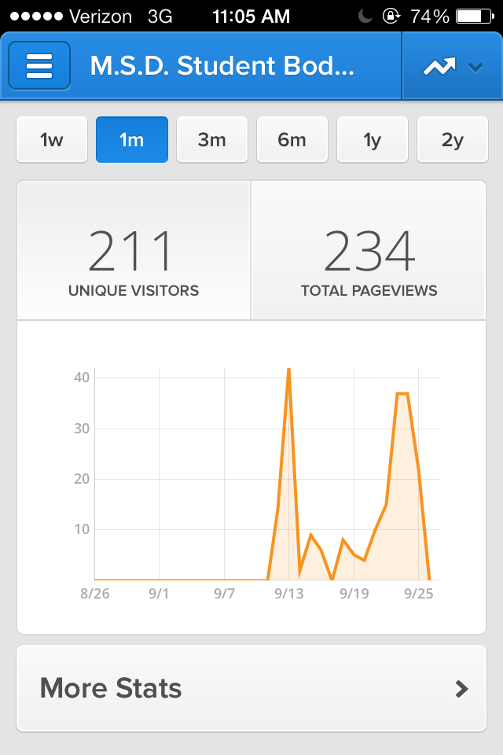

Senior SBG Class Representative Williams: Our class voted the following ideas for Spirit Week: Sports day, zombie day, famous people day, wacky day, and hippie day.

Junior SBG Class Representative Seremeth: (absent) No report

Sophomore SBG Class Representative DeLaCruz: No report

Freshman SBG Class Represetnative Wood-Jacobowitz: My class wants to change their class colors, but due to the new rule that states that any colors that a class chooses and confirms cannot be changed, we were declined the permission to.

SBG Sponsor Nolan: Good job, Secretary Berrigan, for completing our SBG’s first minutes report. Please share this report with Director of Student Affairs Lori Bonheyo, Principal Kevin Strachan, and Assistant Principal Adrienne Rubenstein.
Mr. Larry Newman would like for the SBG President/Vice President to write a short article for the next Maryland Bulletin issue.
Here’s some clarification regarding student members using vending machines. Students who are Student Leaders, SBG members, or of other organizations can only use vending machines when they have pass from their sponsor/s. This can only happen when they are doing some kind of community work during the day (daily meetings are not acceptable).
- OLD BUSINESS
None
- NEW BUSINESS

- Change Class Colors: Voted up 8 – 0 – 0, President Gore and Vice President Ballard will need to bring up this issue with Jimmy DeStefano and Lori Bonheyo.
- Change Spirit Week Ideas (discussed, but not yet voted)

- ANNOUNCEMENTS

- Jad Gore- Homecoming meeting after school at 3pm on Thursday October 3, 2012. All SBG members and representatives are expected to attend.

- MEETING ADJOURNED – 11:31AM

